**Summary of decision-making approaches in Poker Tournament**

**Team 7**

**Pratik Shringarpure**

**Yiyan Wang**

**Ollyting Xin**

## Decision-making approaches in Betting round 1

For the first betting steps, the decision-making approach we determined to implement is the decision tree. The reasons are as followed.

The first reason is that the algorithm of the decision tree is suitable for the first betting round well in our project. As we already learned, a decision tree is made up of connected decision points. The tree should begin at a certain situation which is defined by a decision as a root of the tree. And for each decision followed from the root, there can be a set of options for moving to different branches of the tree. Since the requirement of the betting round is that, in order to get more chance to win the poker game, the AI should be able to take the betting action according to the others betting action (if there is one) and the others’ bet amount, the cards pattern which the AI has, and the amount of ante that the AI can afford. All of these factors can be turned into values which should be checked at the certain points for AI script to make the decisions. All these decisions can be made in a sequence which at each single decision process where there won’t be a combination of Boolean logic but a single value check and then take the decision. Thus, the process which AI takes to make the betting decision match the pattern of the decision tree well.

Another reason is that the decision tree approach is easier and simpler for implementation than other decision-making approaches. Since we weren’t familiar with the poker before, we have spent some time to learn the rules of the five cards draw poker in the meantime as we are learning the decision-making approaches of the AI, so that we can design the structure of our script better. Therefore, we think it should be a good choice to use a simple approach to make an AI which can meet the requirement and be completed in a limited time.

## Decision-making approaches in Draw

The draw method, the decision-making process is achieved by setting conditions for branches.

The first check is to check whether the player has some pair in hand (like One Pair, Two Pair, Three of a Kind, Four of a Kind, Full House). We are doing this because we want our AI to play safely so the AI won’t try to break their hand which already has formed a kind of hand that is better than High Card. If the player has this kind of hand, then the AI will replace the rest of the cards that don’t consist of those hands mentioned above.

If the player doesn’t have a hand that meets the first condition, the second check is to check whether the player has a potential for straight (like only need to replace one card to get a straight). If does, then the AI will replace it. If the player already has a straight or straight flush, the hand value will very close to straight. So, the AI will not replace at all.

If the player doesn’t have a hand that meets the second condition, the third check is to check whether the player has a hand that contains the same suits. If the player has a hand that contains cards with the same suits, then the AI will replace the others to get a Flush or maybe Straight Flush and Royal flush. Because of the drawer principle, every hand must have two cards with the same suits.

So, the three conditions will cover all the situations.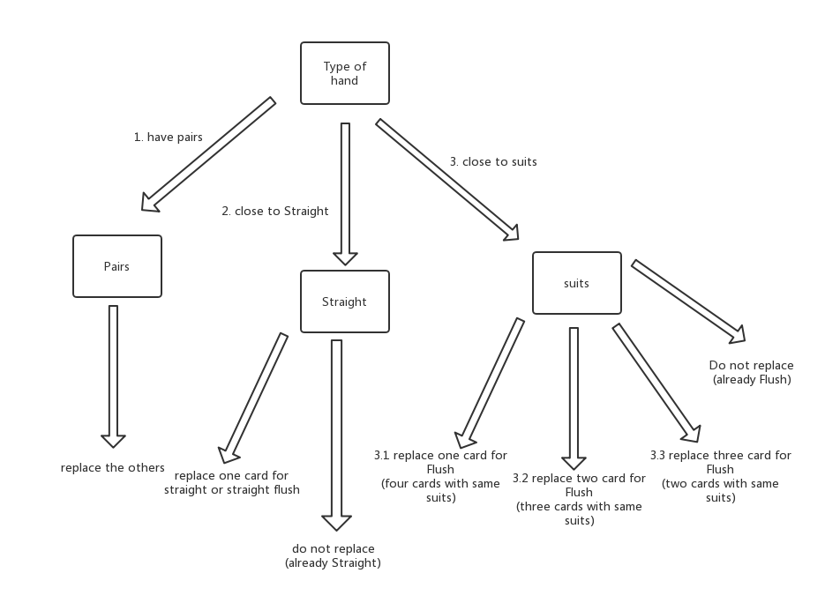

Decision-making in Draw

## Decision-making approaches in Betting round 2

Betting round 2 AI also uses decision tree to make decisions such as call, bet, raise and fold. In round 2, you know all your cards, there is no option for replacing the cards, so you are going to bet using the cards you currently have in your hand.

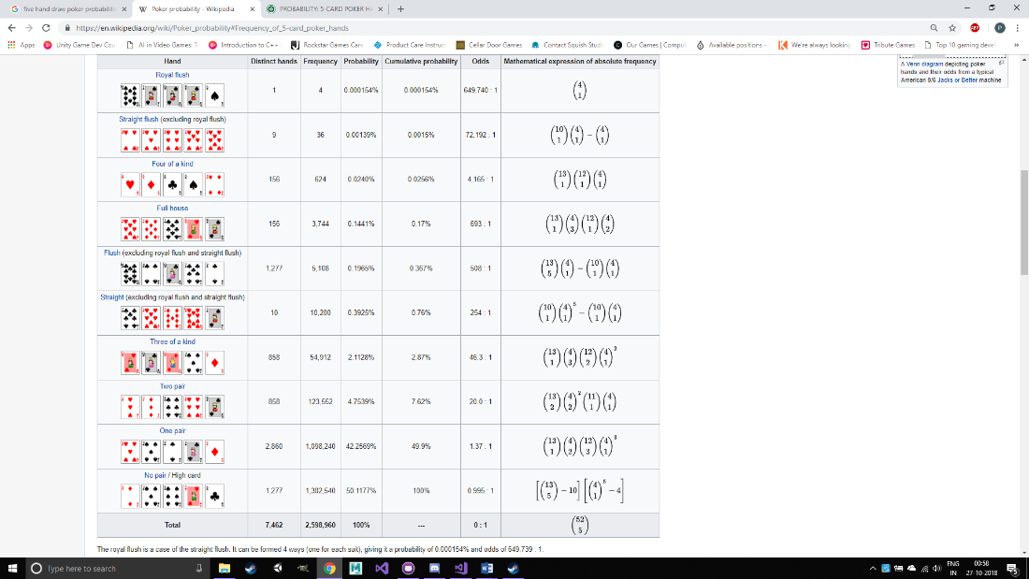

<https://en.wikipedia.org/wiki/Poker_probability#Frequency_of_5-card_poker_hands>

The probabilities of drawing the hands is mentioned above in the image. In the AI, the exact probabilities haven’t been used. The number of distinct hands of each type of draw has been used as to keep the AI simple and easy to test. In round 2, the basic strategy used is to fold cards if you have just a high card and one pair, as the probability of getting these cards is very high and winning on these cards is quite difficult (at least for us, as we have never played poker before this assignment). If the player has flush or straight, then bet more. The reason being these are strong hands and the probabilities of player drawing them is more, so it is more likely to draw it than royal flushes, four of a kind and straight flush. If the AI draws flush or straight, bet more as you are more likely to win.

If you draw royal flush, don’t go all in or you will scare the opponent off and they will fold knowing you drew a very strong hand. But, bet or raise a significant amount to maximize your profit.

Overall, the AI bets without taking too much risks and tries to maximize the opportunities it gets.